IMPACT OF POPULATION GROWTH AND HUMAN-INDUCED DEVELOPMENT ACTIVITIES ON ENVIRONMENTAL DEGRADATION:SUSTAINABLE APPROACHES AGAINST THE VICE GIVING RELEVANT EXAMPLES FROM MY COUNTRY
Introduction
- Population growth and human development activities negatively impact Rangelands, Forests, Swamps and Grasslands through climate change, global warming, fishery depletion and soil degradation leading to environmental degradation in Kenya (Tal, 2025).
- Rapid population growth causes noise pollution, natural resource shortages, stress, depression,violence, diseases and food insecurity (Tal, 2025).
- It is therefore important to put in place sustainable approaches against environmental degradation in Kenya.

Impact of Population Growth and Human-Induced Development Activities on Environmental Degradation
- Deforestation
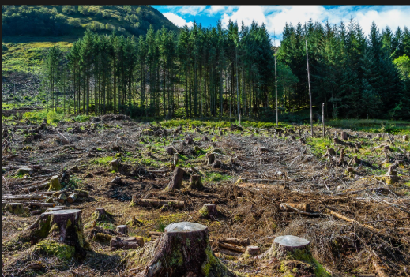
- As population increases, more land is needed to cater for the population.
- Families illegally cut down trees in Mau forests and Aberdare forest to build their homes. Cutting trees is done without planting more trees to replace the trees cut down (Tal, 2025).
- Trees are a source of income since timber can be sold for construction. Wood from trees can be used to make furniture such as wooden tables and wooden chairs sold for profit. Selling of timber and wood furniture is a common source of livelihood especially for people living near forests (Tal, 2025).
- Overpopulation leads to deforestion which may cause drought and famine in the country since trees attract rainfall. Drought and famine are natural disasters in Kenya.
- Several forests in Kenya have been destroyed for human development activities such as Karura Forest in Nairobi, Arabuko Sokoke Forest in Kilifi County, Aberdare Forest, Mau Forest and Mount Kenya Forest (Kimbrough, 2023).
- In Kenya, local communities such as the Kikuyus in Mount Kenya Region use firewood as a source of heat and electricity especially during the cold season when it is snowing on Mount Kenya.
- As population increases the need for land to build houses, source of income, firewood and electricity increases leading to deforestation.

- Pollution
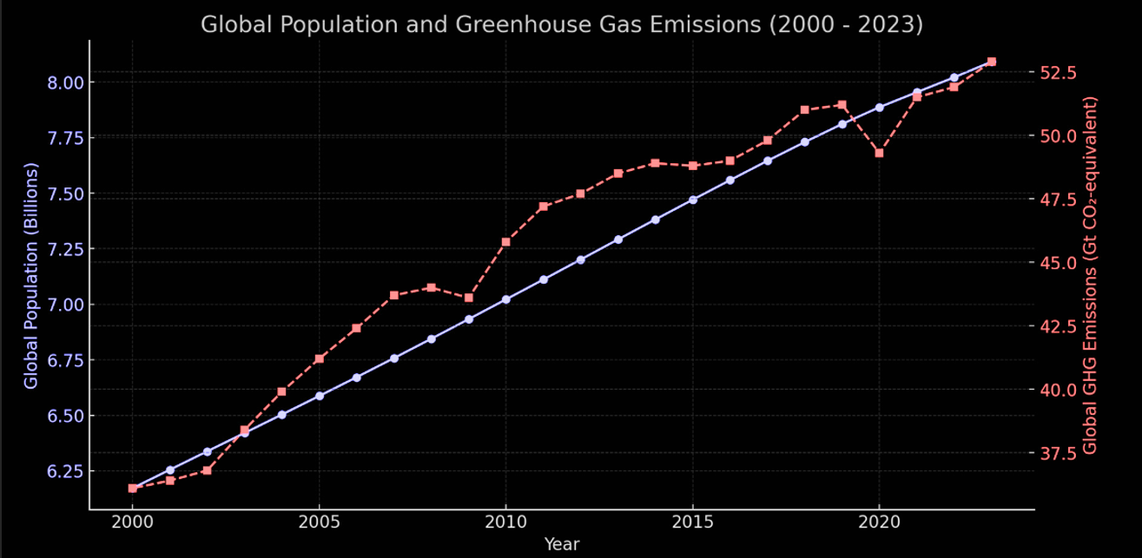

- Poisonous greenhouse gas emissions may leak into the atmosphere killing human beings and other living organisms (Tal, 2025).
- The graph above shows increase in population leads to increase in greenhouse emmissions.
- Increase in population leads to increase in human waste.
- Waste garbage collectors usually dump human waste in one area leading to land pollution.
- Land pollution reduces soil quality leading to loss of lives to animals found in the soil such as earthworms, ants and millipedes (Tal, 2025).
- Waste from industries may leak into water sources such as Lake Naivasha, Lake Victoria, Lake Elementatita and Indian Ocean leading to death of aquatic animals and destruction of coral reefs.
- Human development has lead to people burning down forests making the environment look ugly leading to land and air pollution.
- Population growth has led to increase in pollution through poisonous greenhouse gas emissions, human waste disposal in one area, waste from industries into Indian Ocean and burning down forests leaving ugly sites.

- Decrease in Biodiversity
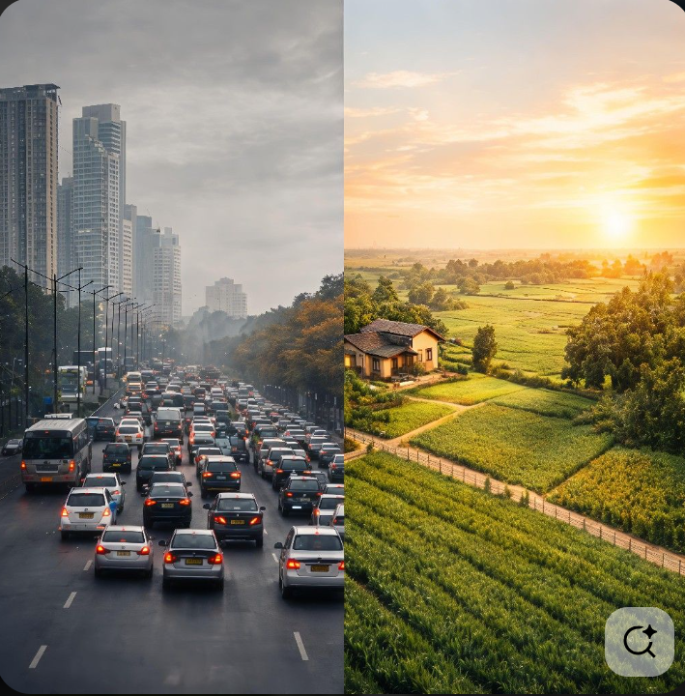
- Increase in Population leads to increase in food consumption.
- Common crops consumed in Kenya include: Maize, beans, wheat, tomatoes and onions. Animals reared as livestock in Kenya are cows, goats, fish,pigs and sheep.
- As population increases,the need for food increases leading to decrease in variety of living organisms in a particular area which may cause extinsion of species.
- Roads and railway lines are built in National Parks for example, Tsavo East National Park has Nairobi-Mombasa Highway and Standard Gauge Railway (SGR) passes through the National Park (kawlaw, 2024).
- Nairobi National Park has the Standard Gauge Railway (SGR) passing throygh the park on a raised bridge.
- railway line and on organisms natural habitat chasing away the animals lead to environmental degradation (Tal, 2025).
- Roads and railway lines are human developments that lead to environmental degradation but are essential for transporting people and goods from one place to another (Tal, 2025).
- Population increase leads to decrease in biodiversity since more common crops are consumed, livestock rearing increases, both leading to extinsion of species and increase in roads and railway lines for transporting people and goods from one place to another causing environmental degradation.

- Overfishing
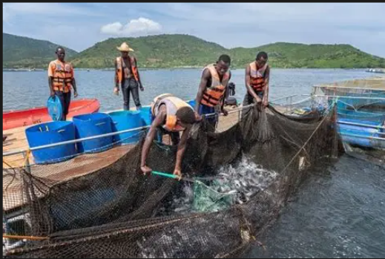
- People in Kisumu County eat Fish as their staple food since they are surrounded by Lake Victoria, a fresh water lake commonly known for Tilapia (Tal, 2025).
- As population increases the need for protein, a key element in a balanced diet increases. Fishing is done as a source of income.
- Human greediness has increased over the years since one is never satisfied with what they have leading to overfishing.
- Overfishing negatively impacts the future generation from being able to eat fish as a source of food (Tal, 2025).
- Protein, fish meat is eaten in large amounts by body builders to increase in muscle size.
- Cod liver oil obtained from fish is rich in vitamin D used in strengthening bones and helps the body fight against diseases (myhealthopedia.com, 2025).

- Water Scarcity
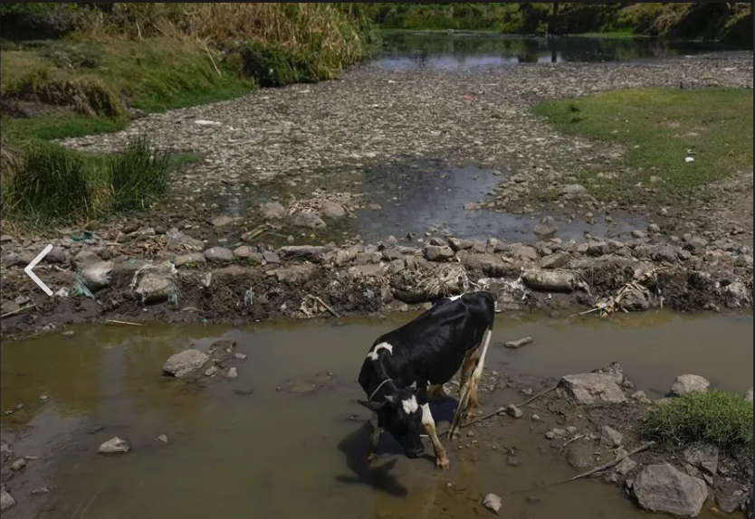
- Population growth leads to increase in water scarcity.
- Humans need water for drinkimg preventing dehydration which may cause death.
- Water is needed for irrigation of crops, livestock such as sheep and goats drink water to remain alive.
- Wild animals, plants and other living organisms need water to live.
- Increase in population leads to increase in need of water causing water scarcity in overpopulated towns such as Nairobi and Kiambu.
- Permanent rivers are now seasonal rivers making some fish species move to other rivers leading to decline in fish as a result of water scarcity.
- Some seasonal rivers during the dry season dry off completely making the land look bare and ugly leading to Environmental degradation.

Sustainable Approaches Against Environmental Degradation with Relevant Examples from Kenya
- Creating Public Awareness
- If people are made aware of the importance of taking care of the environment such as trees adding oxygen to the atmosphere they would appreciate and take care of the environment. Advertisements on Methods of Conserving the Environment could be put in local television stations such as Citizen Televishion, Kenya Broadcasting Corporation (KBC), Nation Television(NTV) and Kenya Television Network(KTN).
- These advertisements reach many people at the same time ensuring everyone gets informed on Methods of Conserving the Environment preventing Environmental Degradation.
- The youth are the future of tomorrow. Most young people can be reached through social apps such as TikTok, Snapchat, Instagram and Youtube Shorts.
- In social apps one could watch short videos during ones free time on conserving the environment preventing Environmental Degradation.

- Government Involvement
- The government could set aside a day in every 2 months where children, the working popuation and the elderly could plant trees where previous trees were cut down. For every one tree cut down, three more trees should be planted.Everyone is involved as it is a collective responsibility.
- Imposing heavy fines on people who misuse the environment by polluting water bodies such as Lake Victoria and Lake Turkana can act as a great motivator for conserving the environment.
- The government spends less in taking care of the environment when the community gets involved, funds that were not used go to other sectors of the economy such as the education sectors, more universities and colleges are built, increasing literacy among Kenyans leading to increased development in the country.

- Wildlife Conservation
- The government should restrict human settlement in forests such as Mau Forest and Aberdare Ranges. Human settlement in Mau forest is dangerous as one can be killed by wild animals such as Lions, Cheetahs, Crocodiles.These wild animals hunt humans for prey easy for them to attack when humans encroach their habitat.
- Hardwood trees should be protected because they take a very long time to grow, their beauty and rareness attract tourists enabling Kenya earn foreign exchange.
- The government should punish whoever is found poaching wild animals such as elephants for their tusks used to make jewellery and rhinos for their horns which are a treasure in Asian countries such as China and South Korea (Mwanzu et al., 2023).

- Community Involvement
- When the community gets to see how they can benefit economically from the environment, the local community gets hand on in taking care of the environment.
- Instead of exhaustibly cutting down trees leaving the soil bare causing soil erosion they cut down trees in moderation replacing every tree that was cut down preventing Environmental degradation.

- Waste Management and Recycling
- People living in the coastal region such as Mombasa and Malindi could picking up non biodegradable waste such as plastics and glass bottles in Indian Ocean.
- Many industries are found in towns such as Nairobi, Kiambu, Mombasa, Eldoret and Embu can recycle trash thrown away by human beings such as plastic, glass and metal, make new products out of them selling the new products to the locals. This leads to more job opportunities reducing level of poverty in Kenya preventing Environmental degradation.

- Water Resource Conservation
- Coral Reefs take a very long time to grow especially hard corals. These corals are very expensive hence the government should properly secure them.Prevent tourists from picking these corals since the government earns revenue when tourists visit the country.
- Freshwater lakes should be kept clean by local communities since they are a source of drinking water, washing clothes,water to plant crops and rear livestock preventing economic degradation.

Conclusion
- Population growth has caused deforestation, pollution, decrease in biodiversity, overfishing and water scarcity leading to environmental degradation.
- Human-induced development activities such as construction of roads and railway lines in Tsavo East National Park, Construction of Houses in Mau Forest, selling of valuable corals from Indian Ocean, and overfishing in Lake Victoria have led to environmental degradation.
- Sustainable approaches can be put in place to curb environmental degradation such as creating public awareness, government involvement, community involvement, wildlife conservation, waste management and recycling and water resource conservation.

References
Tal, A. (2025). The Environmental Impacts of Overpopulation. Encyclopedia, 5(2), 45. https://doi.org/10.3390/encyclopedia5020045
Kimbrough, L. (2023, November 7). Deforestation continues in Kenya’s largest water capturing forest, satellites show. Conservation News. https://news.mongabay.com/2023/11/deforestation-continues-in-kenyas-largest-water-capturing-forest-satellites-show/
Tennakoon, W. D. N. M. S., Janadari, M. P. N., & Wattuhewa, I. D. (2024). Environmental sustainability practices: A systematic literature review. European Journal of Sustainable Development Research, 8(3), em0259. https://doi.org/10.29333/ejosdr/14604
Mwanzu, A., Nguyu, W., Nato, J., & Mwangi, J. (2023). Promoting Sustainable Environments through Urban Green Spaces: Insights from Kenya. Sustainability, 15(15), 11873. https://doi.org/10.3390/su151511873
myhealthopedia.com. (2025, June 27). Cod Liver Oil: 20 Health Benefits, Side Effects, Dosage & How to Take It. https://myhealthopedia.com/cod-liver-oil-benefits-side-effects-dosage-uses/
kawlaw. (2024, February 18). Tsavo East & Tsavo West | Location, Gates & Getting There. Kenya Tsavo Safaris. https://www.kenyatsavosafaris.com/location-getting-there/

